**CT30A2803 User Interfaces and Usability**

**Assignment 3 – Prototyping**

Trieu Huynh Ba Nguyen

Trieu.Huynh.Ba.Nguyen@student.lut.fi

***Chapter 1: Application and design pattern***

a) Explain which kind of application you are prototyping:

The application I chose for this assignment is a website for an online store. The website would display all products that are offered; customers of the store can select an item to read descriptions or reviews and add the item to their cart.

b) Select a design pattern and explain how it solves an interface design problem:

The website will follow the design pattern “Feature, Search, and Browse”. One common problem is that an online store might have an extremely large selection of products, and their website is confusing and not logically designed. Customers will often feel “lost” when they browse through an endless list of unrelated items. Without an appropriate tool to assist them in looking for a product, the customers will feel discouraged to continue, eventually leaving the website for another options.

This design pattern will make it easier for the customers to navigate the site and find desired items by grouping products into relevant categories and enabling a search function. The customers can select a category from the panel located at the left edge of the site to see suggested products belonging to that category. If the customers wish to search for a specific item, then they can enter some keywords into the search bar to look up for items with names or descriptions matching the given keywords.

***Chapter 2: Prototyping***

a) Prototype (at wireframe level) one simple interface twice:

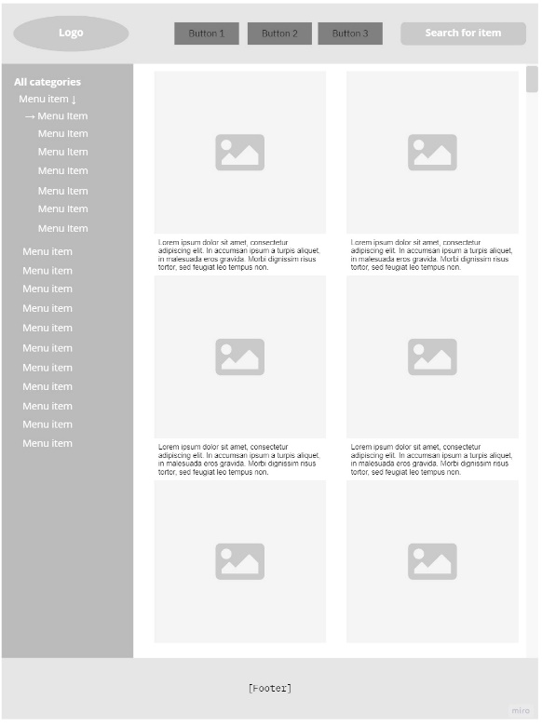

Figure 2. Portrait orientation of the interface

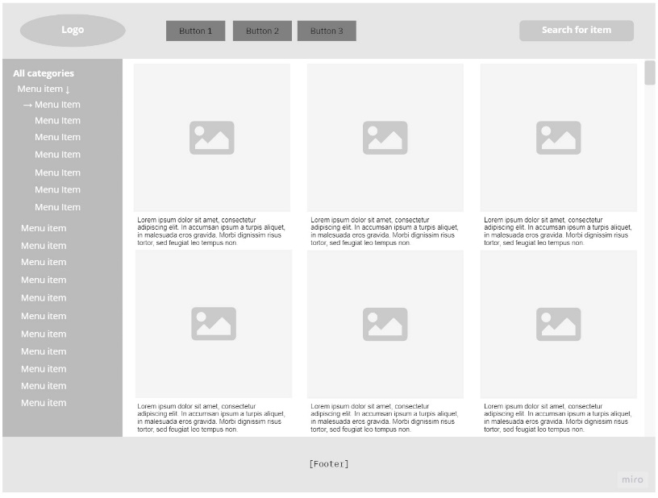

Figure 1. Landscape orientation of the interface

b) Explain how the prototype follows the principles of responsive design:

According to Aryal (2014), responsive web design should follow these principles:

* Fluid grids: Relative sizing is utilized to fit contents to screen size. By keeping the interface simple, uniformed, and straight-forward, it could easily be scaled to accommodate a wide range of screen resolutions. A fixed object on the interface could be turned into a size relative to its display space.
* Media queries: Different styles of the interface are applied to better fit the screen size. As we are not actually designing a website, the wireframe prototype interface above illustrates how contents could be modified to be logically displayed either in horizontal or vertical mode. The configuration of images and descriptions of each item is transformed from a 3x2 grid to a 2x3 grid to better accommodate contents.
* Flexible images and media: Images and other media should load differently for every resolution. Every item’s image and description on the interface is displayed within its own “box”. With scaling, the maxi-mum width of a media element can be set to 100 percent, causing the browser to shrink or extend it depending on the “box”. Cropping, on the other hand, hides a piece of the image while keeping it within the dimensions of the “box”.

***Chapter 3: Aesthetic design***

a) Apply two aesthetic design principles on a subset of the interface:

Figure 3. Interface with aesthetic design principles

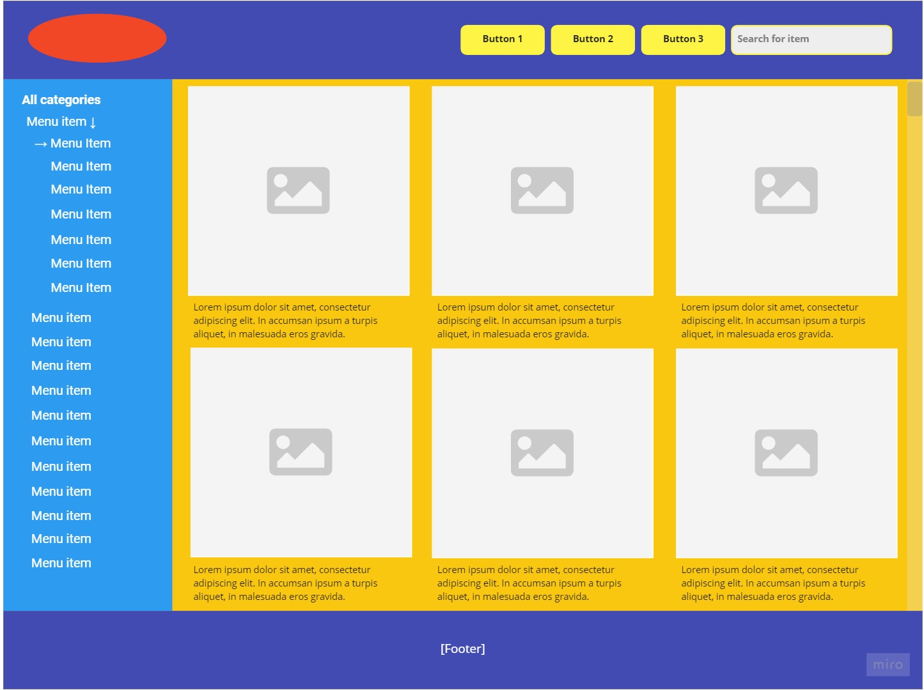

b) Briefly explain your aesthetic choice:

Three primary aesthetic design principles were used for the interface:

* Emphasis: All items are placed on a dark yellow background, surrounded by blue elements. This layout helps the items to stand out and emphasizes them, making them much more appealing to the customers.
* Color theory: The interface adheres to the triad color scheme: red, blue, and yellow. This scheme is great for web design as they contrast from each others. Being bold and bright, they will leave a long-lasting impression on the customers when they visit the website.
* Typography: The website uses two fonts: Open Sans and Roboto. These are Sans Serif fonts, which are easily readable for a responsive web design. The colors of characters are black for bright backgrounds and white for cool backgrounds. These design styles make characters not only stand out but also be attractive and eye-catching.

# **Citations:**

ARYAL, C., S., 2014. *Design* Principles for Responsive Web. Bachelor’s Thesis, Metropolia University of Applied Sciences, Helsinki.